 **AEPHY**

**Centripetal and Gravitational Motion Class Test (5%)**

**Student Name:_____________________________**

**Note: Students have 55 minutes to complete the test**

**Total Marks___/55**

1. A car is moving at a constant speed around a flat circular track. Which of the following options (A, B, C or D) best describes the velocity, acceleration and net force acting on the car. **[ 1 mark ]**

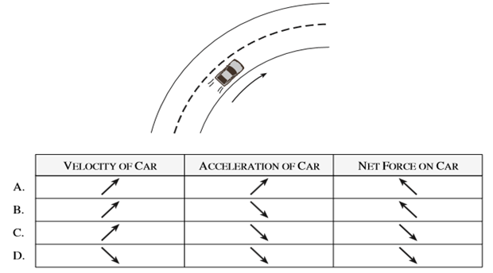

1. 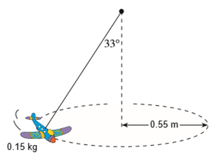A 0.15 kg toy airplane is suspended on a string and is travelling in a horizontal circle at a constant speed as shown in the diagram to the right.
2. What is its centripetal force? **[ 4 marks ]**
3. What is the period of its motion? **[ 5 marks ]**



1. Calculate the Tension in the rope when the toy airplane is flying on the moon in exactly the same pattern as shown in the diagram in part a). **[ 4 mark]**
2. A physics student swings a 500 g pail of water in a vertical circle of radius 1.30 m. As shown in the diagram to the right.
3. 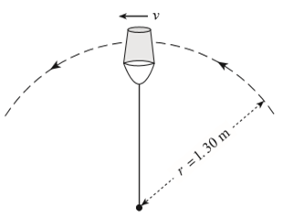What is the minimum speed, vmin at the top of the circle if the water is not to spill from the pail? **[ 3 marks ]**
4. If the velocity increases so that the bottom of the pail exerts a normal force of 2.45 N on the water when it is on the top of the swing, what is the pails new velocity? [ **4 marks ]**
5. 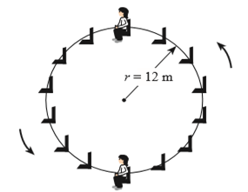The diagram to the right shows a 52 kg child riding on a Ferris wheel of radius 12 m and period 18s.
6. What is the apparent weight of the child at the top of the ride? **[ 5 marks ]**
7. What is the apparent weight of the child at the **bottom** of the ride? **[ 4 marks ]**

1. A bicycle and its rider have a total mass of 85 kg and travel around a circular banked track at a radius of 20 m and at a constant speed of 10 m/s, as shown in Figure 1 below. The track is banked and there is no sideways friction force applied by the track on the wheels.

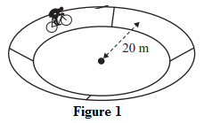

1. Draw on the diagram below the forces acting on the bicyclis. Make sure to label your force vectors. **Do not** show any net or component forces. **[ 2 marks ]**

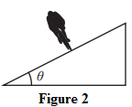

1. Calculate the correct angle of the bank needed for the riders to travel at 10 m/s at a radius of 20 m, if we assume friction is not contributing to the centripetal force. **[ 4 marks ]**
2. Explain the difference between apparent weightlessness and zero gravity giving examples where each could occur. [ **4 marks total**]

_____________________________________________________________________________________

_____________________________________________________________________________________

_____________________________________________________________________________________

_____________________________________________________________________________________

_____________________________________________________________________________________

_____________________________________________________________________________________

_____________________________________________________________________________________

_____________________________________________________________________________________

_____________________________________________________________________________________

______________________________________________________________________________________________

1. 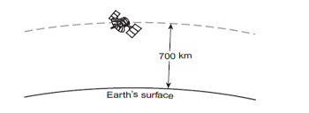An 8.87x104 kg satellite is orbiting the Earth at an altitude of 700 km. Assume the satellite is in a stable orbit.
2. What is the orbital speed of this satellite? [ **4 marks** ]
3. a) Derive Kepler’s third law. Your derivation must start with two forces. **[ 3 marks ]**

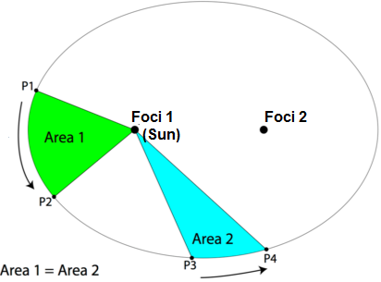Use the diagram below to answer parts b) and c) of this question. Please note the area sectors labelled Area 1 and 2 are equal areas. Use Kepler’s Laws to answer the questions below about this diagram.

1. Compare the velocity of the object as it moves from P1 to P2 versus when it moves from P3 to P4. Explain why the velocities are different or similar. [ **2 marks** ]

_________________________________________________________________________________

_________________________________________________________________________________

_________________________________________________________________________________

1. Compare the time taken for the object to move from P1 to P2 versus the time to move from P3 to P4. State which of Kepler’s Laws you applied to answer this question. [ **2 marks** ]

____________________________________________________________________________________

____________________________________________________________________________________

1. If the period of a satellite orbiting the Earth is 36 hours, what is the orbital radius (radial distance from the centre of the Earth) for this satellite? **[ 4 marks ]**